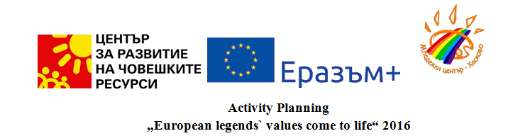

 | WEDNESDAY  04. 05. | THURSDAY  05. 05. | FRIDAY  06. 05. | SATURDAY  07. 05. | SUNDAY  08. 05.
BREAKFAST |  | Hotel | Hotel | Hotel | Hotel
M  O  R  N  I  N  G | Arrival of the participants. | Opening and introductory session for the participants. | Meeting with representatives of the local authorities, volunteersand institutions.  Press-conference. | A workshop to explore the Polish legends in mixed groups. | A workshop to explore Italian legends in mixed groups.
M  O  R  N  I  N  G | Arrival of the participants. | Talk: „Opportunities for intercultural development.“ Presentation of Youthpass. | Bulgarian folk holiday- St. George in the village of Trakietz. Participation in rituals. | A workshop to explore the Polish legends in mixed groups. | A workshop to explore Italian legends in mixed groups.
LUNCH | Hotel | Hotel | Picnic | Hotel | Hotel
A  F  T  E  R  N  O  O  N | Arrival of the participants. | Youth workshops about  discussions of intercultural development. | Ourdoor team building. | Co-presentation of Polish legends in groups. | Presenting the Italian legends and myths.
A  F  T  E  R  N  O  O  N | Arriving to the hotel and accommodation. |  | Ourdoor team building. | Creative workshop for ideas about the intercultural legend „Once upon a time ...“ | Creating a Facebook page. Working in small groups and preparing the interculture legend.
DINNER | Welcome dinner | Hotel | Restaurant | Hotel | Hotel
N  I  G  H  T |  | Intercultural evening with authentic Bulgarian dinner. Welcome party. | A concert about the national holiday of Bulgaria- 6. Mai.  Party. | Poland evening-culture, music, dance and cuisine. | Italian evening- music, culture, cuisine and dances.
 | MONDAY  09. 05. | TUESDAY  10. 05. | WEDNESDAY  11. 05. | THURSDAY  12. 05. | FRADAY  13. 05.
BREAKFAST | Hotel | Hotel | Hotel | Hotel | Hotel
M  O  R  N  I  N  G | Visit to the cultural and historical sites in the Old Town of Plovdiv. | Workshop for the introduction of legends and myths from Slovakia in mixed groups. | A visit to „The Alexander tomb“ and meeting with scientists from the Museum of Haskovo. | Workshop for discussing ideas about future common initiatives. | Prepare suitcases.
M  O  R  N  I  N  G |  |  | A visit to the church in Uzundzhovo. Discussion: „European values of legends come to life.“ | An assessment and a formal closure of the project. | Prepare suitcases.
LUNCH | Outdoors | Hotel | Picnic | Hotel | Hotel
A  F  T  E  R  N  O  O  N | Workshop presentation of the Bulgarian legends in the Ethnographic Museum, in the city of Plovdiv. | Co-presentation of the legends of the Slovak group. | Youth workshop for organizing, preparing and arranging the photo exhibition and preparing a presentation. | Closing session of Youthpass. | Goodbye.  Travel to the airport.
A  F  T  E  R  N  O  O  N |  | Outdoor activities, sport. |  | A presentation about the common intercultural legend „Once upon a time ...“ | Goodbye.  Travel to the airport.
DINNER | Hotel | Hotel | Hotel | Hotel
N  I  G  H  T | Bulgarian evening - culture, music, cuisine. | Slovak culture, music, dances and cuisine. | An evening campfire- „Legends speak ...“ presented by the countries participating. | An international evening of friendship.

